'Programmer: Samantha Naini
'Date: 3/15/2012
'Exercise: 4-4-21 pg.152
'Program Purpose: Create a program processing someone's major, year, and languages selected.

Private Sub btnRecord_Click(ByVal sender As System.Object, ByVal e As System.EventArgs) Handles btnRecord.Click

Dim majorSelected As Boolean
Dim yearSelected As Boolean

If lstMajors.Text = "" Then
majorSelected = False
Else
majorSelected = True
End If

If (radFreshman.Checked Or radSophmore.Checked Or radJunior.Checked Or radSenior.Checked) Then

yearSelected = True
Else
yearSelected = False

End If

If majorSelected And yearSelected Then
MessageBox.Show("Your information has been processed.")

ElseIf Not majorSelected Then
If Not yearSelected Then
MessageBox.Show("Please select a major and year.")
Else
MessageBox.Show("Please select a major.")
End If
Else
MessageBox.Show("Please select a year.")
End If

End Sub
End Class

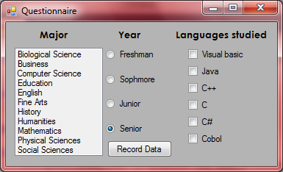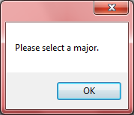←When only year is selected
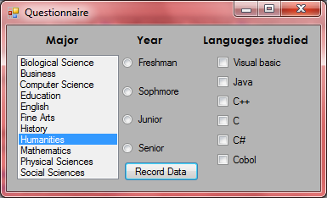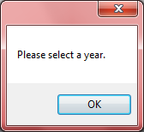←when only major is selected
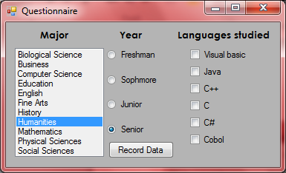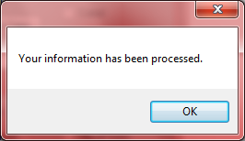←When both major and year are selected
'Programmer: Samantha Naini
'Date: 3/15/2012
'Exercise: 4-4-22 pg.152
'Program Purpose: Create a program processing someone's major, year, and languages selected.

Option Strict On
Option Explicit On

Public Class frmQuestionnaire

Private Sub btnRecord_Click(ByVal sender As System.Object, ByVal e As System.EventArgs) Handles btnRecord.Click
Dim sentence As String = Nothing
If lstMajors.Text = Nothing Then
MessageBox.Show("No major was selected.", "4-4-22")
End If
If radFreshman.Checked = False And radSophmore.Checked = False And radJunior.Checked = False And radSenior.Checked = False Then
MessageBox.Show("No year was selected.", "4-4-22")
End If
If chkC.Checked Then
sentence = "C"
End If
If chkCobol.Checked Then
sentence &= "Cobol"
End If
If chkCPlus.Checked Then
sentence &= "C++"
End If
If chkCSharp.Checked Then
sentence &= "C#"
End If
If chkJava.Checked Then
sentence &= "Java"
End If
If chkVisBasic.Checked Then
sentence &= "Visual Basic"
End If
If sentence = Nothing Then
MessageBox.Show("No languages studied.", "4-4-22")
Else
MessageBox.Show("The following languages studied: " & sentence & ".", "4-4-22")
End If
End Sub

Private Sub btnEnd_Click(ByVal sender As System.Object, ByVal e As System.EventArgs) Handles btnEnd.Click
If MsgBox("Do you really want to quit?", MsgBoxStyle.YesNoCancel, "Quit") = MsgBoxResult.Yes Then
MessageBox.Show("Have a nice day!", "Quit")
Me.Close()
End If
End Sub

Private Sub btnClear_Click(ByVal sender As System.Object, ByVal e As System.EventArgs) Handles btnClear.Click
lstMajors.SelectedItem = Nothing
radFreshman.Checked = False
radSophmore.Checked = False
radJunior.Checked = False
radSenior.Checked = False
chkC.Checked = False
chkCobol.Checked = False
chkCPlus.Checked = False
chkCSharp.Checked = False
chkJava.Checked = False
chkVisBasic.Checked = False
End Sub
End Class

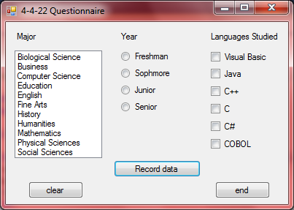
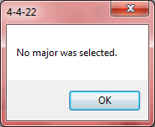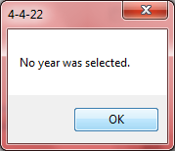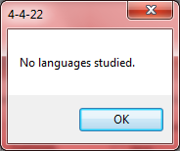

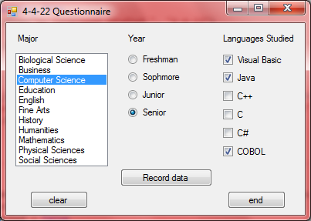
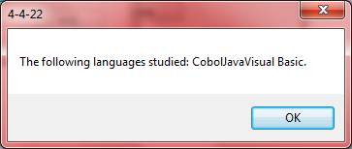
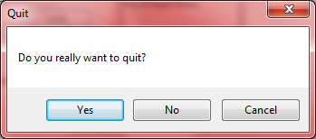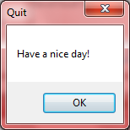

'Programmer: Samantha Naini
'Exercise: Chapter 4 Programming Project 1
'Date: 3/26/2012
'Program purpose: Eddie's Equipment Rental & Bill

Option Strict On
Option Explicit On

Public Class frmEquipRental

Dim dblRugCleanerH As Double = 16
Dim dblRugCleanerF As Double = 24
Dim dblLawnMowerH As Double = 12
Dim dblLawnMowerF As Double = 18
Dim dblPaintSprayerH As Double = 20
Dim dblPaintSprayerF As Double = 30
Dim dblDeposit As Double = 30

Private Sub btnDisplayRentals_Click(ByVal sender As System.Object, ByVal e As System.EventArgs) Handles btnDisplayRentals.Click

Dim fmtStr As String = "{0, -20} {1,-13:C} {2,-13:C}"
With lstPrices.Items.Clear()
.Add(String.Format(fmtStr, "Price of Equipment", "Half-day", "Full-day"))
.Add(String.Format(fmtStr, "1. Rug cleaner", dblRugCleanerH, dblRugCleanerF))
.Add(String.Format(fmtStr, "2. Lawn mower", dblLawnMowerH, dblLawnMowerF))
.Add(String.Format(fmtStr, "3. Paint sprayer", dblPaintSprayerH, dblPaintSprayerF))
End With
End Sub

Private Sub btnDisplayBill_Click(ByVal sender As System.Object, ByVal e As System.EventArgs) Handles btnDisplayBill.Click
Dim strItem, strDuration, strItemSelected, strMessage, fmtStr As String
Dim dblItemPrice As Double

'Textbox inputs:
strItem = txtItem.Text
strDuration = txtDuration.Text.ToUpper.Substring(0, 1)

Select Case strItem & strDuration

Case "1H"
strItemSelected = "Rug cleaner"
dblItemPrice = dblRugCleanerH
Case "1F"
strItemSelected = "Rug cleaner"
dblItemPrice = dblRugCleanerF
Case "2H"
strItemSelected = "Lawn mower"
dblItemPrice = dblLawnMowerH
Case "2F"
strItemSelected = "Lawn mower"
dblItemPrice = dblLawnMowerF
Case "3H"
strItemSelected = "Paint sprayer"
dblItemPrice = dblPaintSprayerH
Case "3F"
strItemSelected = "Paint sprayer"
dblItemPrice = dblPaintSprayerF
Case Else
MessageBox.Show("I'm sorry, but the values you entered are invalid. Please try again.", "Try again")
txtDuration.Clear()
txtItem.Clear()
End Select

If strDuration = "H" Then
strMessage = "(Half-day rental)"
Else
strMessage = "(Full-day rental)"
End If
With lstBill.Items.Clear()
.Add(String.Format(fmtStr, "Receipt from Eddie's Equipment Rental", "", ""))
.Add(String.Format(fmtStr, strItemSelected, dblItemPrice, strMessage))
.Add(String.Format(fmtStr, "Deposit", dblDeposit, ""))
.Add("")
.Add(String.Format(fmtStr, "Total", dblItemPrice + dblDeposit, ""))

End With

End Sub

Private Sub btnClear_Click(ByVal sender As System.Object, ByVal e As System.EventArgs) Handles btnClear.Click
lstPrices.Items.Clear()
lstBill.Items.Clear()
txtItem.Clear()
txtDuration.Clear()
txtItem.Focus()
End Sub

Private Sub btnEnd_Click(ByVal sender As System.Object, ByVal e As System.EventArgs) Handles btnEnd.Click
Me.Close()
End Sub
End Class
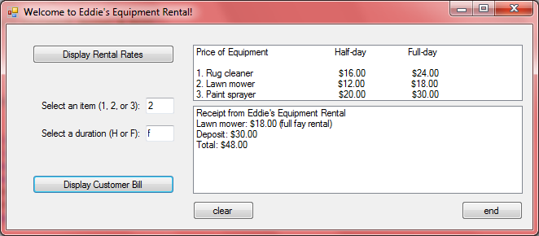
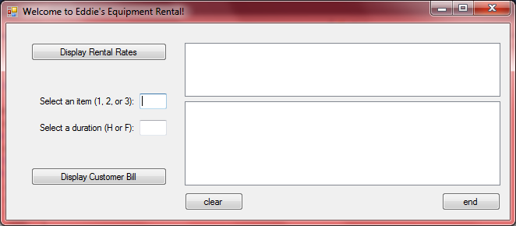←clear button
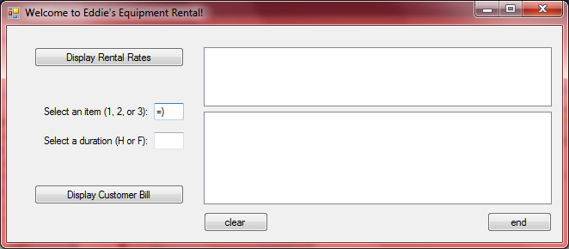
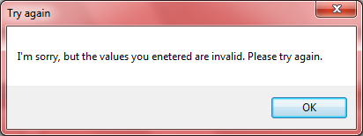
'Programmer: Samantha Naini
'Exercise: Chapter 4 Programming Project 2
'Date: 3/15/2012
'Program purpose: To calculate a food item's percent calories from fat.

Option Strict On
Option Explicit On

Public Class frmNutrition

Private Sub btnCompute_Click(ByVal sender As System.Object, ByVal e As System.EventArgs) Handles btnCompute.Click

Dim strNameOfFood, strLimit As String
Dim dblCalories, dblGramsOfFat, dblPctOfCalories As Double

If txtNameOfFood.Text = Nothing Or txtCalories.Text = Nothing Or txtGramsOfFat.Text = Nothing Then

MsgBox("One or more of the data input is blank. please try again!")
Else
strNameOfFood = txtNameOfFood.Text
dblCalories = CDbl(txtCalories.Text)
dblGramsOfFat = CDbl(txtGramsOfFat.Text)

dblPctOfCalories = dblGramsOfFat * 9 / dblCalories

If dblPctOfCalories > 0.3 Then

strLimit = " exceeds "
Else
strLimit = " does not exceed "
End If
With lstOutput.Items.Add("" & strNameOfFood & " contains " & Format(FormatPercent(dblPctOfCalories, 2)) & " from fat.")
lstOutput.Items.Add("" & strNameOfFood & "" & strLimit & " the AHA recommendation.")
End With
End If
End Sub

Private Sub btnClear_Click(ByVal sender As System.Object, ByVal e As System.EventArgs) Handles btnClear.Click
txtNameOfFood.Clear()
txtNameOfFood.Focus()
txtCalories.Clear()
txtGramsOfFat.Clear()
lstOutput.Items.Clear()
End Sub

Private Sub btnEnd_Click(ByVal sender As System.Object, ByVal e As System.EventArgs) Handles btnEnd.Click
If MsgBox("Do you really want to quit?", MsgBoxStyle.YesNoCancel, "Quit") = MsgBoxResult.Yes Then
MessageBox.Show("Have a nice day!", "Quit")
Me.Close()
End If
End Sub
End Class
